**THE SPACE MAZE RUNNER**

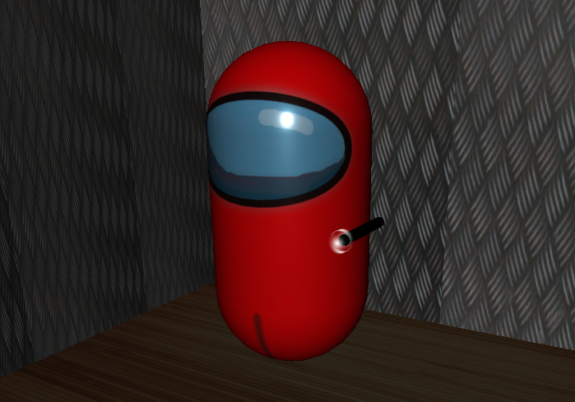

Hi, I’m Red and I need your help to escape this maze. I woke up today in a strange place with high walls and barely any light to see. Fortunately, I have a flashlight with me to see in the dark but I keep getting lost. I don’t remember how I got here but I do know a few things:

1. There is a hover-ship parked at the exit and that is my way out of here.

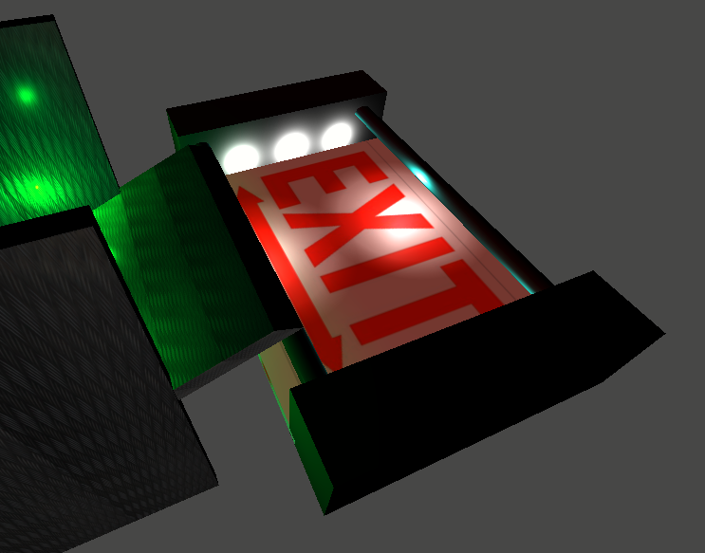

1. My flashlight has good enough range of light.
2. I can move around with arrow keys or the ‘WASD’ keys and look around using the mouse.
3. I have access to a top view camera and I can switch to it using the ‘C’ key.
4. I have a map of this maze and you can find it at the end of this document.
5. 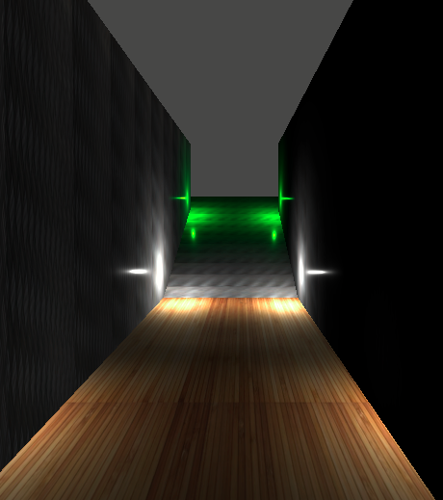There are green lights at the exit.

Help me find my way to the ship, I’m counting on you!

THE MAP

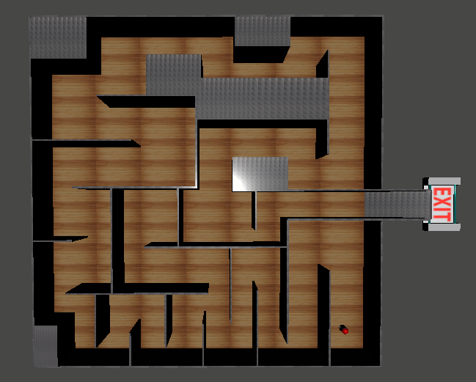

I am Here